flutter 页面布局 Paddiing Row Column Expanded 组件详解

（

一、 Flutter Paddiing 组件 1

二、 Flutter Row 水平布局组件 3

三、 Flutter Column 垂直布局组件 6

四、 Flutter Expanded 类似 Web 中的 Flex 布局 8

五、 Flutter 实现类似下面的布局 11

六、 Vscode 调试 Flutter 项目 11

一、Flutter Paddiing 组件

- html 中常见的布局标签都有 padding 属性，但是 Flutter 中很多 Widget 是没有 padding 属

性。这个时候我们可以用 Padding 组件处理容器与子元素直接的间距。

属性 | 说明
padding | padding 值, EdgeInsetss 设置填充的值
child | 子组件


class LayoutDemo extends StatelessWidget {

@override

Widget build(BuildContext context) {

return Padding(

padding: EdgeInsets.fromLTRB(0, 0, 10, 0),

child: GridView.count(
、、



crossAxisCount: 2,

childAspectRatio: 1.5,

children: <Widget>[

Padding(

padding: EdgeInsets.fromLTRB(10, 10, 0, 0),

child: Image.network('https://www.itying.com/images/flutter/1.png',

fit: BoxFit.cover),

),

Padding(

padding: EdgeInsets.fromLTRB(10, 10, 0, 0),

child: Image.network('https://www.itying.com/images/flutter/2.png',

fit: BoxFit.cover),

),

Padding(

padding: EdgeInsets.fromLTRB(10, 10, 0, 0),

child: Image.network('https://www.itying.com/images/flutter/3.png',

fit: BoxFit.cover),

),

Padding(

padding: EdgeInsets.fromLTRB(10, 10, 0, 0),

child: Image.network('https://www.itying.com/images/flutter/4.png',

fit: BoxFit.cover),

),

Padding(

padding: EdgeInsets.fromLTRB(10, 10, 0, 0),

child: Image.network('https://www.itying.com/images/flutter/5.png',

fit: BoxFit.cover),

),

Padding(

padding: EdgeInsets.fromLTRB(10, 10, 0, 0),

child: Image.network('https://www.itying.com/images/flutter/6.png',

fit: BoxFit.cover),

),

],

),

);

}

}
、

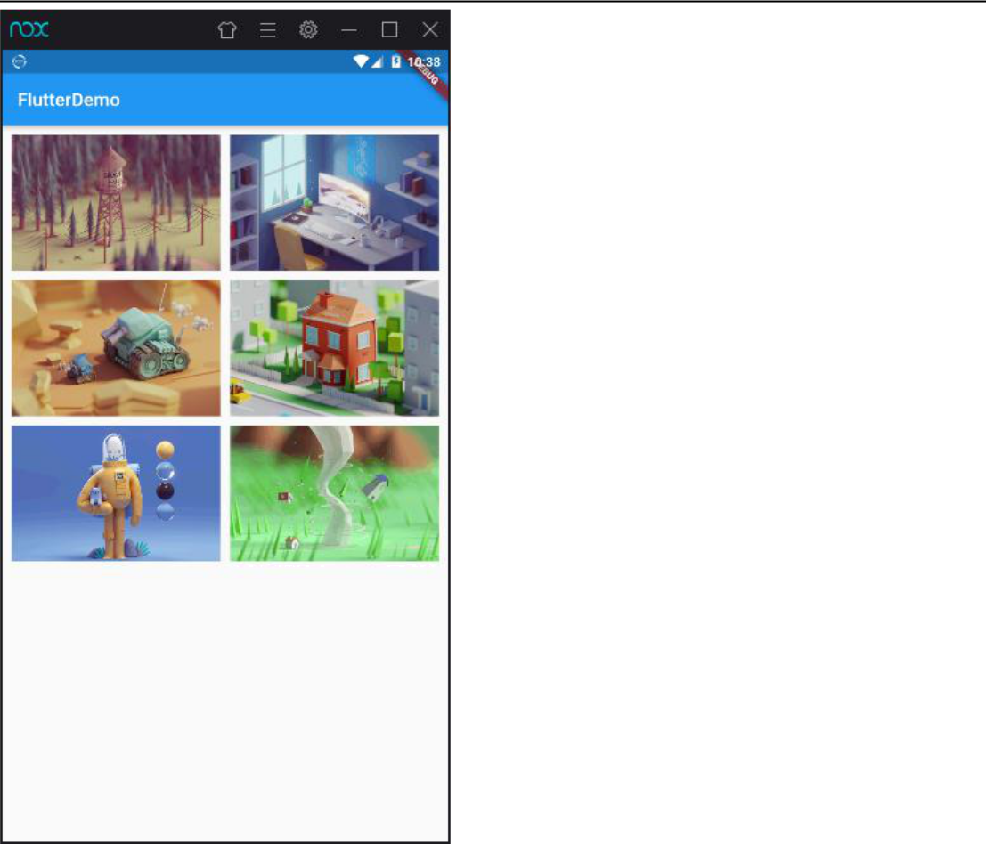

二、Flutter Row 水平布局组件

属性 | 说明
mainAxisAlignment | 主轴的排序方式
crossAxisAlignment | 次轴的排序方式
children | 组件子元素
import 'package:flutter/material.dart';
void main() => runApp(MyApp());
class MyApp extends StatelessWidget {
@override
Widget build(BuildContext context) {
// TODO: implement build
return MaterialApp(
home: Scaffold(


appBar: AppBar(title: Text('FlutterDemo')),

body: LayoutDemo(),

));

}

}

class LayoutDemo extends StatelessWidget {

@override

Widget build(BuildContext context) {

return Container(

height: 700,

width: 500,

color: Colors.black26,

child: Row(

crossAxisAlignment: CrossAxisAlignment.center,

mainAxisAlignment: MainAxisAlignment.spaceEvenly,

- crossAxisAlignment: CrossAxisAlignment.center, children: <Widget>[
IconContainer(Icons.home,color:Colors.red),

IconContainer(Icons.search,color:Colors.blue),

IconContainer(Icons.send,color:Colors.orange),

],

),

);

}

}

class IconContainer extends StatelessWidget{

double size;

IconData icon;

Color color;

IconContainer(this.icon,{this.size,this.color=Colors.blue}){

this.size=32.0;

}

@override

Widget build(BuildContext context) {

- TODO: implement build return Container(
width: this.size+60,

height: this.size+60,

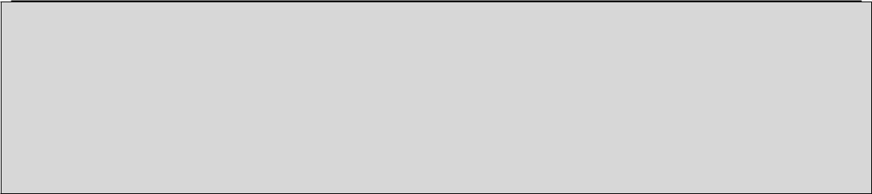

color:this.color,

child: Center(child: Icon(this.icon,color:Colors.white,size:this.size))

);

}

}
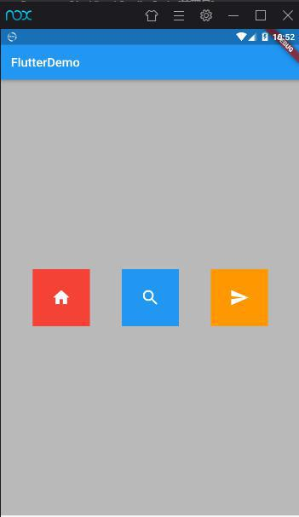

三、Flutter Column 垂直布局组件

属性 | 说明
mainAxisAlignment | 主轴的排序方式
crossAxisAlignment | 次轴的排序方式
children | 组件子元素


import 'package:flutter/material.dart';

void main() => runApp(MyApp());

class MyApp extends StatelessWidget {

@override

Widget build(BuildContext context) {

- TODO: implement build return MaterialApp(
home: Scaffold(

appBar: AppBar(title: Text('FlutterDemo')),

body: LayoutDemo(),

));

}

}

class LayoutDemo extends StatelessWidget {

@override

Widget build(BuildContext context) {

return Container(

height: 700,

width: 500,

color: Colors.black26,

child: Column(

crossAxisAlignment: CrossAxisAlignment.center,

mainAxisAlignment: MainAxisAlignment.spaceEvenly,

- crossAxisAlignment: CrossAxisAlignment.center, children: <Widget>[
IconContainer(Icons.home,color:Colors.red),

IconContainer(Icons.search,color:Colors.blue),

IconContainer(Icons.send,color:Colors.orange),

],



),

);

}

}

class IconContainer extends StatelessWidget{

double size;

IconData icon;

Color color;

IconContainer(this.icon,{this.size,this.color=Colors.blue}){

this.size=32.0;

}

@override

Widget build(BuildContext context) {

- TODO: implement build return Container(
width: this.size+60,

height: this.size+60, color:this.color,
child: Center(child: Icon(this.icon,color:Colors.white,size:this.size))

);

}

}

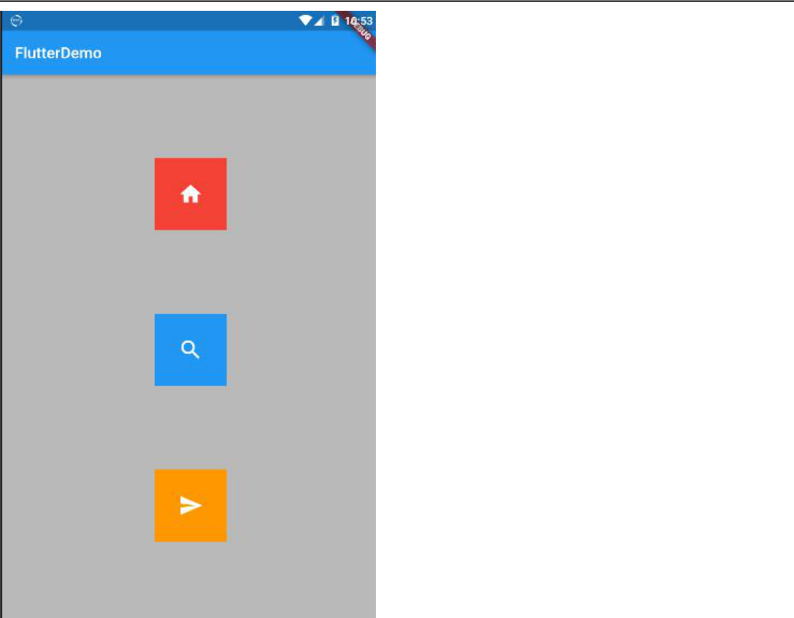

四、Flutter Expanded 类似 Web 中的 Flex 布局

Expanded 可以用在 Row 和 Column 布局中

属性 | 说明
flex | 元素站整个父 Row /Column 的比例
child | 子元素

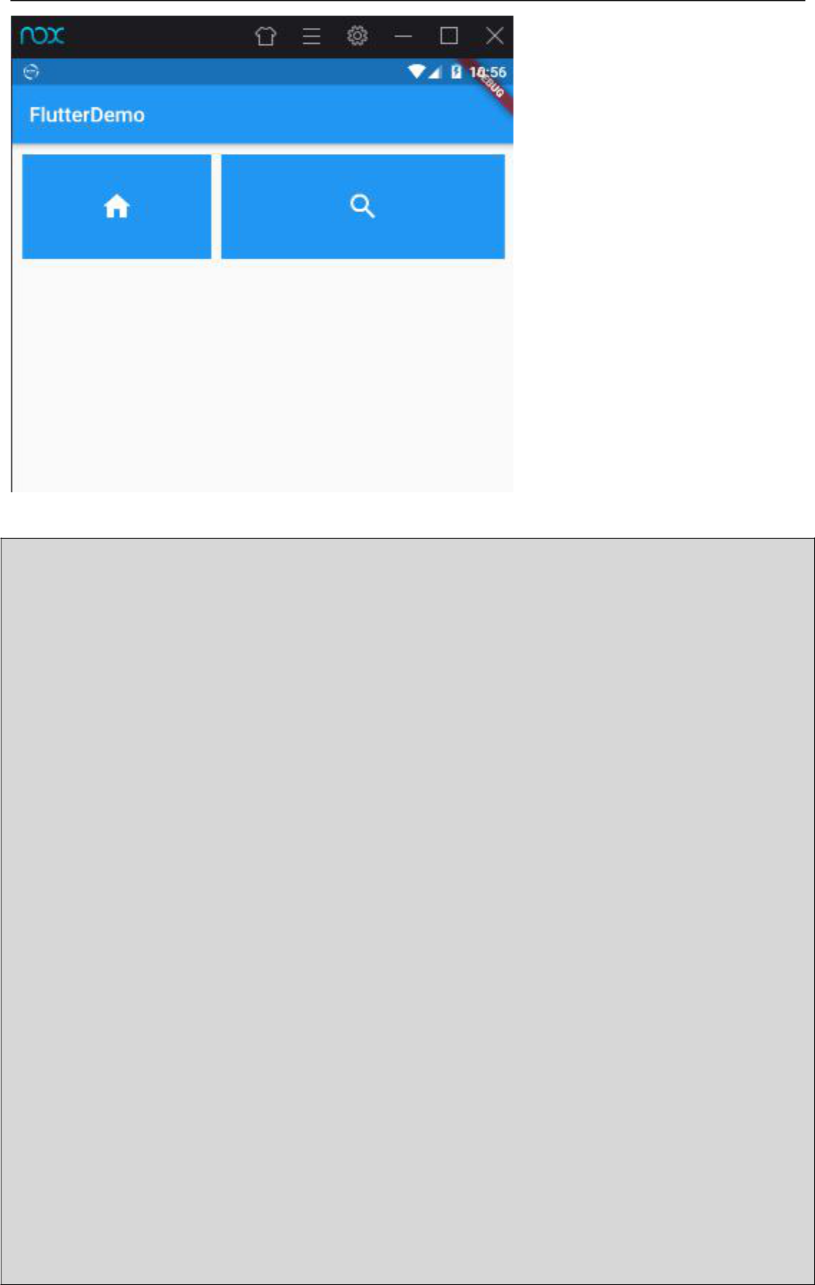

import 'package:flutter/material.dart';

import 'res/listData.dart';

void main() => runApp(MyApp());

class MyApp extends StatelessWidget {

@override

Widget build(BuildContext context) {

- TODO: implement build return MaterialApp(
home: Scaffold(

appBar: AppBar(title: Text('FlutterDemo')),

body: LayoutDemo(),

));

}

}

class LayoutDemo extends StatelessWidget {

@override

Widget build(BuildContext context) {

return Padding(

padding: EdgeInsets.all(10),

child: Row(

- crossAxisAlignment: CrossAxisAlignment.start, mainAxisAlignment: MainAxisAlignment.center,



- crossAxisAlignment: CrossAxisAlignment.center, children: <Widget>[
Expanded(flex:2,child: IconContainer(Icons.home)),

SizedBox(width: 10),

Expanded(flex: 3,child: IconContainer(Icons.search)),

  - SizedBox(width: 10),

  - Expanded(child: IconContainer(Icons.send))

],

),

)

;

}

}

class IconContainer extends StatelessWidget{

double size;

IconData icon;

IconContainer(this.icon,{this.size}){

this.size=32.0;

}

@override

Widget build(BuildContext context) {

- TODO: implement build return Container(
width: 100.0,

height: 100.0,

color: Colors.blue,

child: Center(child: Icon(this.icon,color:Colors.white,size:this.size))

);

}

}

五、Flutter 实现类似下面的布局
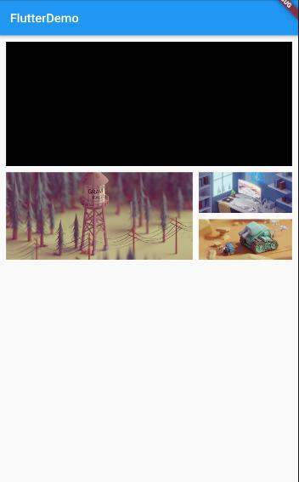

六、Vscode 调试 Flutter 项目

1、Vscode 中打开 flutter 项目进行开发

2、运行 Flutter 项目

flutter run

- 键：点击后热加载，也就算是重新加载吧。

- 键：显示网格，这个可以很好的掌握布局情况，工作中很有用。

- 键：切换 android 和 ios 的预览模式。 q 键：退出调试预览模式。

3、Vscode 默认连不上第三方模拟器解决方案

cd 到对应夜神模拟器 D:\Program Files\Nox\bin 目录 然后运行

nox_adb.exe connect 127.0.0.1:62001

